Accommodations: InterContinental Berlin
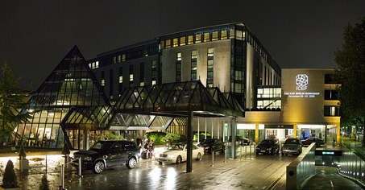
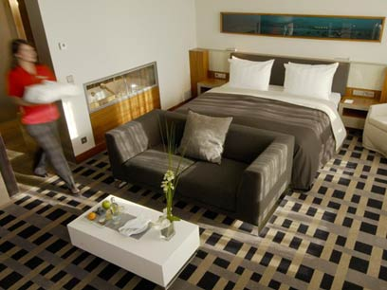
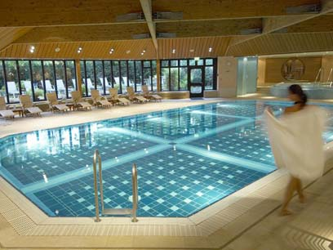
The InterContinental Berlin has struck an impressive pose on the city skyline for nearly half a century. A better location is hard to imagine, with the government quarter, historic center, shopping districts and Berlin’s important sites just minutes away. You’ll walk to Potsdamer Platz, Kurfürstendamm boulevard, Memorial Church and the Reichstag. The InterContinental's 530 guestrooms and 54 suites provide world-class luxury and elegance plus superlative layouts and brilliantly executed interior design.

The hotel offers its guests a range of pleasures for the appetite, including the fine dining restaurant Hugos, the restaurant L.A. Cafe, which features international and Chinese cuisine, and of course the Marlene Bar, which is a popular gathering place for all Berliners.

The hotel has 37 conference rooms, as well as Berlin's largest ballroom to host any event. An exceptional spa and a gymnasium can also be availed by the guests for their physical and mental well being.

What’s Nearby?
- Potsdamer Platz / New City Center with Sony Center (2 KM / 1.24 MI )
- Reichstag (4 KM / 2.49 MI )
- Brandenburger Tor/Brandenburg Gate/Pariser Platz (4.5 KM / 2.8 MI )
- Castle Charlottenburg (3 KM / 1.86 MI )
- Museum Island, Berlin Cathedral (6.5 KM / 4.04 MI )
- Siegessaeule (2 KM / 1.24 MI )
- Gedaechtniskirche / Memorial Church (0.5 KM / 0.31 MI )
- Gendarmenmarkt with French Dome (4 KM / 2.49 MI )
- Zoological Garden (1.3 KM / 0.81 MI )
- Kurfuerstendamm renowned shopping district (0.5 KM / 0.31 MI )
- Park Tiergarten (0.3 KM / 0.19 MI )
- KaDeWe - largest department store of Europe (0.5 KM / 0.31 MI )

The Appleton Group Room Rates
€224: Superior Room
€251: Deluxe Room
Rate includes full breakfast buffet each morning

Online Reservation
www.intercontinental.com
Enter your travel information and the Group Code TAG

CONTACT InterContinental Berlin
Budapester Strasse 2, Berlin 10787, Germany
Hotel Front Desk: 49-30-26020 | Hotel Fax: 49-30-26022600

