GUEST SPEAKERS

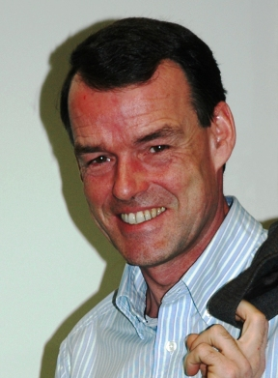
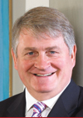

Denis O'Brien
Entrepreneur

Denis O'Brien is one of Ireland’s leading entrepreneurs with extensive international telecoms, radio, property, aircraft leasing and golf/leisure interests. In 1991 Mr O’Brien founded the Esat Telecom Group and built it throughout the 1990’s until its sale to British Telecom in 2000 for €2.4 billion.

In 2001 Mr O’Brien established Digicel which has extended its GSM network to twenty countries in the Caribbean region and plans are advanced to increase this to 22 countries by the end of 2006. Digicel is one of the fastest growing cellular companies in the world. An affiliate, Digicel Pacific Ltd., has recently been awarded licences in Samoa, Fiji and Papua New Guinea.

Mr. O’Brien is also the founder of the Communicorp Group, which manages a portfolio of broadcasting companies in Ireland and in seven European countries.

Outside his business interests, Mr. O’Brien chaired the 2003 Special Olympics World Summer Games in Ireland and he is the Chairman and Co-Founder of Frontline, the International Foundation for the Protection of Human Rights Defenders. The O’Brien and Digicel Foundations also assist projects in the Third World, with the aim to alleviate poverty in communities in Africa as well as Haiti, Jamaica and Grenada. Mr. O’Brien is also a Director of Concern Worldwide.

Peter Fleming
Founding Director
Ridley Fleming

Peter is one of the founding directors of Ridley Fleming, a firm which specializes in business and management development consultancy and training for professional firms. Ridley Fleming has over 10 years of experience of working with law firms from niche through to magic circle, and provides support for over 2000 lawyers each year in the UK and continental Europe.
Peter’s many years commercial experience (Managing Director, Divisional General Manager and Group Marketing Director) for several leading PLC's brought him into regular working contact with professional advisors (legal, financial and accounting). His first hand experience of IPO, MBO and Business Strategy at Group and Operating level ensures Ridley Fleming consultancy and training services incorporate a realistic and pragmatic 'client perspective'.
In addition to his management responsibilities, he continues to provide Ridley Fleming clients with consultancy services, particularly in the areas of Business Development and Strategic Marketing. He oversees the firm’s evaluation programme and has worked with Cognisco of Cranfield to develop the unique business development evaluation tool AFinsite.

