MARK HO admitted in China (1989) and the State of North Carolina (1994)  PROFESSIONAL EXPERIENCE:  2005- Now Partner, Jade & Fountain, Shanghai  2000-2005 Chief Counsel, McDonald's China  1994-2000 Associate, O'Melveny & Myers Shanghai and Hong Kong  1989-1991 Associate, Shanghai United Law Offices  Assisted foreign investors in acquiring Chinese assets or foreign assets located in China; assisted multinational clients in their Chinese investment, outsourcing and business operation activities, including setting up rep offices, JVs and WFOEs; and represented major retail clients in acquiring over 500 real estate premises in over 100 Chinese cities, including purchasing land, buildings and factory facilities.  Provided counsel on Chinese law compliance issues such as environmental, safety, human resources, licensing or permitting, marketing, and distribution issues; represented clients in liaison with Chinese government agencies and government proceedings; assisted major distribution clients in setting up Chinese distribution, logistics and retail operations in China.  Provided counsel on trademark licenses, retail licenses and franchising transactions; assisted clients in conducting franchising in China.  Represented clients in numerous dispute resolution proceedings such as CIETAC arbitration and court proceedings including employment issues.  EDUCATION:  University of Georgia School of Law  LL.M, 1993  Institute of Law, Shanghai Academy of Social Sciences  LL.M, 1989  Renmin University of China, Beijing  LL.B, 1986 | 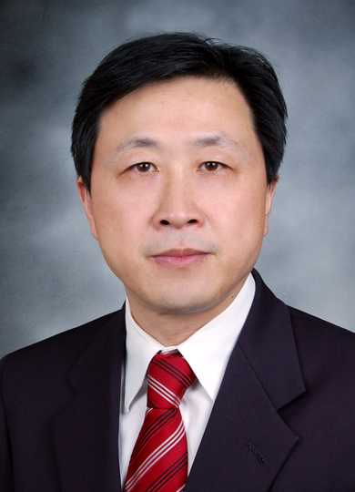  Partner  Telephone: 86-21-62351887  Facsimile: 86-21-62351477  E-Mail: mark.ho@jadefountain.com

