 FOR IMMEDIATE RELEASE

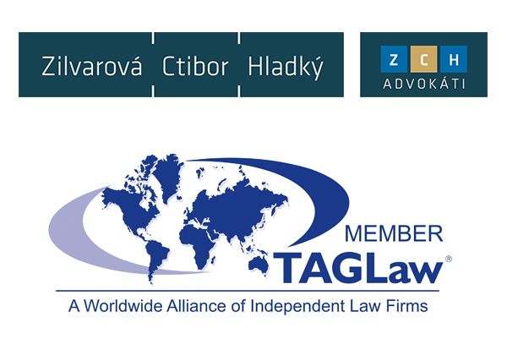**TAGLaw Welcomes Kuri Breña, Sanchez Ugarte y Aznar in Mexico**

***Mexico is the Latest in a Series of Additions by the Top Tier International Alliance of 155 Law Firms.***

St. Petersburg, Florida (November 24, 2015) - TAGLaw® continues its global growth through the addition of Kuri Breña, Sanchez Ugarte y Aznar (Kuri Breña) as its new member in Mexico. This addition brings TAGLaw’s overall global reach to 155 members employing 9,500 lawyers in 330 offices throughout 86 countries.

Delegates from Kuri Breña were formally introduced to TAG Alliances members at its recent International Conference in Santa Monica, California on October 26-28, 2015.

“We are proud to welcome a highly regarded firm such as Kuri Breña,” said Richard Attisha, President of TAGLaw and the TAG Alliances. “In the weeks leading up to becoming a member, the partners of Kuri Breña made themselves available to a number of our members who needed assistance in Mexico. Their responsiveness and professionalism are the hallmarks of what a TAGLaw member should exemplify in their practice. This is a great addition for our members, and I know Kuri Breña will benefit from their new international alliance.”

“This is a time of continuous challenges where law firms are looked upon not only to provide quality services through the most experienced practice groups in their countries, but also to ensure access to complete, integrated networks with the strongest platforms of experts around the world,” said Daniel Kuri Breña, founding partner of Kuri Breña. “We are confident that our membership with TAGLaw will contribute to our firm taking advantage of the many great opportunities presented in these demanding times.”

In addition to Kuri Breña in Mexico, TAGLaw made international gains by recently welcoming Perlman Vidigal Godoy Advogados in Brazil and Tamrat Assefa Liban Law Offices in Ethiopia.

###

**About TAGLaw and The TAG Alliances™**

Founded in 1998, TAGLaw is an international alliance of high-quality, independent law firms. In 2015, Chambers Global ranked the alliance “Elite”, the highest ranking awarded to legal networks. The TAG Alliances comprise three groups: TAGLaw, TIAG® (The International Accounting Group), and TAG-SP™. TIAG is an international alliance of high quality, independent accounting firms and TAG-SP is a complementary association of strategic business partners. Collectively, the TAG Alliances provide accounting, legal, financial and business support services on a worldwide scale. With approximately 17,000 professionals in 280 member firms, and 590 offices in over 100 countries, the TAG Alliances serve tens of thousands of clients from all industry and commercial sectors. Learn more at [www.TAGLaw.com](http://www.TAGLaw.com).

**About Kuri Breña, Sanchez Ugarte y Aznar**

Kuri Breña, Sanchez Ugarte y Aznar is recognized in Mexico as a firm that provides legal services of the highest quality through a team of lawyers with solid professional backgrounds and a sophisticated business vision. In addition the firm’s general practice in corporate, financial and business matters, they have specialized advisors for tax and antitrust matters. The firm services clients that are leaders in their various industries. At the international level, the firm offers services to public and private companies located in the United States, Canada, Latin America, Europe and Asia. Learn more at [www.ksa.mx](http://www.ksa.mx).

**Media Contact**

Chris Cervellera, Senior Director of Marketing and Technology  
[ccervellera@TAGLaw.com](mailto:ccervellera@TAGLaw.com)  
+ 1 727 895 3720