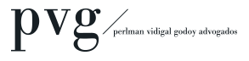FOR IMMEDIATE RELEASE

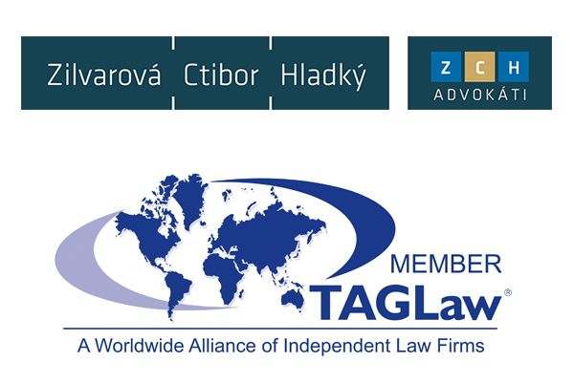**TAGLaw Welcomes Perlman Vidigal Godoy Advogados in Brazil**

***International Alliance of 155 Law Firms Leverages Strong Latin American Contacts to Add Brazilian Member.***

St. Petersburg, Florida (November 24, 2015) - TAGLaw® continues its global growth by recently admitting Perlman Vidigal Godoy Advogados as its new member in Brazil. This addition brings TAGLaw’s overall global reach to 155 members encompassing 9,500 lawyers in 330 offices throughout 86 countries.

PVG and its partners are highly ranked by Chambers Global, Chambers Latin America, Legal 500, and IFLR1000. Furthermore, several of the firm's partners and associates have postgraduate degrees from prestigious universities in the United States and Europe.

“PVG came highly recommended to us by a number of our members in Latin America,” said Richard Attisha, President of TAGLaw and the TAG Alliances. “The firm is a dynamic and energetic group of professionals. With Brazil being one of the key emerging markets in the world, we were determined to find a capable and like-minded partner in Brazil, and we have found as much, and more, in PVG.”

“We are greatly honored to become the new Brazilian members of TAGLaw, said Marcelo Perlman, partner of PVG. “Since introductions were kindly made by Jonás Bergstein of Bergstein Abogados in Uruguay, all our interactions with the alliance representatives have indicated that TAGLaw is a first class group, run by a thoughtful and efficient team of professionals, with impressive business development and networking offerings, and comprised of leading internationally-minded firms. Our impressions have since been confirmed by most encouraging reports on TAGLaw given by different partners of member firms whom we had the chance to meet at the recent IBA annual conference in Vienna. The opportunity to join TAGLaw has thus been enthusiastically embraced and we eagerly look forward to meeting fellow participants in all TAG alliances at the upcoming Spring conference in Lisbon.”

In addition to PVG in Brazil, TAGLaw made international gains by recently welcoming Kuri Breña, Sanchez Ugarte and Aznar in Mexico and Tamrat Assefa Liban Law Offices in Ethiopia.

###

**About TAGLaw and The TAG Alliances™**

Founded in 1998, TAGLaw is an international alliance of high-quality, independent law firms. In 2015, Chambers Global ranked the alliance “Elite”, the highest ranking awarded to legal networks. The TAG Alliances comprise three groups: TAGLaw, TIAG® (The International Accounting Group), and TAG-SP™. TIAG is an international alliance of high quality, independent accounting firms and TAG-SP is a complementary association of strategic business partners. Collectively, the TAG Alliances provide accounting, legal, financial and business support services on a worldwide scale. With approximately 17,000 professionals in 280 member firms, and 590 offices in over 100 countries, the TAG Alliances serve tens of thousands of clients from all industry and commercial sectors. Learn more at [www.TAGLaw.com](http://www.TAGLaw.com).

**About Perlman Vidigal Godoy Advogados (PVG)**

PVG, founded in June 2010, is led by partners with extensive experience and entrepreneurial minds. The firm aims to provide legal services with outstanding quality and efficiency and build long term partnerships with its clients. PVG is divided between a transactional practice, concentrating on capital markets, corporate law, banking, contracts and mergers and acquisitions (M&A), a civil and regulatory litigation and advisory practice, and a tax advisory and litigation practice.. Learn more at [www.pvg.com.br](http://www.pvg.com.br).

**Media Contact**

Chris Cervellera, Senior Director of Marketing and Technology  
[ccervellera@TAGLaw.com](mailto:ccervellera@TAGLaw.com)  
+ 1 727 895 3720