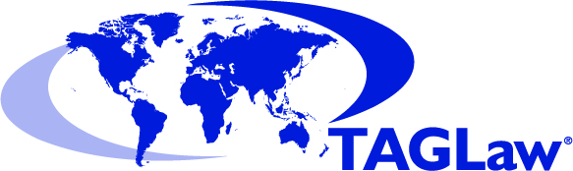

AGENDA
TAGLaw Partner Meeting

 |  | Action
1. | Conferences & Events
 | - International conference, [LOCATION] October 20XX  - XXX Regional Conference, March 20XX  - International conference, [LOCATION], May 20XX  (Check www.TAGLaw.com for dates and locations.) | ALL
2. | TAGLaw Admin | ALL
- Referrals In/Out from TAG Alliances members
(Who do we need to be meeting or introducing clients to?)
- TAG Academy Seminars or Events
(Check www.TAGAcademy.com and www.TAGAlliances.com/webinars.)
3. | TAG Specialty Groups Updates | ALL
4 | Individual Firm / Jurisdiction Visits (TAGLaw, TIAG & TAG-SP) | ALL
5. | Announcements and Materials for TAGLaw Website | ALL
- Firm News
- Practice or Industry Articles
- Success Stories from TAG Alliances members
- Social Media (Twitter [other members], LinkedIn [TAG Alliances Group])
- Check TAGLaw firm profile for any updates
6. | AOB | ALL
- Review of action points etc.
- Communicate Items of Note to Firm and Clients

